|  |  |
| --- | --- |
| **Assignment 2**  **Due Date 23 Feb 2023 Max. Marks 10** | |
| Course: B. Tech(Hons) | Machine Learning Using Python |

Q1. Suppose there is a marketing company A, who does various advertisement every year and get sales on that. The below list shows the advertisement made by the company in the last 5 years and the corresponding sales:

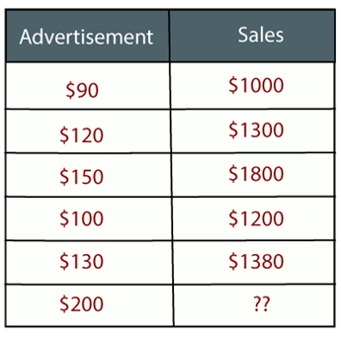

Now, the company wants to do the advertisement of $200 in the year 2019 **and wants to know the prediction about the sales for this year**.

# Q2. The Art Competition has entries from three painters: Pam, Pia and Pablo

# Pam put in 15 paintings, 4% of her works have won First Prize.

# Pia put in 5 paintings, 6% of her works have won First Prize.

# Pablo put in 10 paintings, 3% of his works have won First Prize.

# What is the chance that Pam will win First Prize?

**Q3.** Let us take an example of the last 10 days weather dataset with attributes outlook, temperature, wind, and humidity. The outcome variable will be playing cricket or not. We will use the ID3 algorithm to build the decision tree.

| **Day** | **Outlook** | **Temperature** | **Humidity** | **Wind** | **Play cricket** |
| --- | --- | --- | --- | --- | --- |
| 1 | Sunny | Hot | High | Weak | No |
| 2 | Sunny | Hot | High | Strong | No |
| 3 | Overcast | Hot | High | Weak | Yes |
| 4 | Rain | Mild | High | Weak | Yes |
| 5 | Rain | Cool | Normal | Weak | Yes |
| 6 | Rain | Cool | Normal | Strong | No |
| 7 | Overcast | Cool | Normal | Strong | Yes |
| 8 | Sunny | Mild | High | Weak | No |
| 9 | Sunny | Cool | Normal | Weak | Yes |
| 10 | Rain | Mild | Normal | Weak | Yes |
| 11 | Sunny | Mild | Normal | Strong | Yes |
| 12 | Overcast | Mild | High | Strong | Yes |
| 13 | Overcast | Hot | Normal | Weak | Yes |
| 14 | Rain | Mild | High | Strong | No |

# ​

**Q4.** Suppose we have height, weight and T-shirt size of some customers and we need to predict the T-shirt size of a new customer given only height and weight information we have. Data including height, weight and T-shirt size information is shown below -

|  |  |  |
| --- | --- | --- |
| **Height (in cms)** | **Weight (in kgs)** | **T Shirt Size** |
| 158 | 58 | M |
| 158 | 59 | M |
| 158 | 63 | M |
| 160 | 59 | M |
| 160 | 60 | M |
| 163 | 60 | M |
| 163 | 61 | M |
| 160 | 64 | L |
| 163 | 64 | L |
| 165 | 61 | L |
| 165 | 62 | L |
| 165 | 65 | L |
| 168 | 62 | L |
| 168 | 63 | L |
| 168 | 66 | L |
| 170 | 63 | L |
| 170 | 64 | L |
| 170 | 68 | L |

# New customer named 'Monica' has height 161cm and weight 61kg. What is the Size of T Shirt?.

# Q5. The values of independent variable X and dependent variable Y are given below:

# X Y

# 2

# 3

# 5

# 4

# 6

# Find the least square regression line y=mx+c, Estimate the value of Y when X is 10.

# Q6. Consider a linear regression model with n=3 and d=1 with input output pairs as follows: y1=2, x1=1, y2=3, x2=1, y3=3, x3=2.

# What is the gradient of mean square error(MSE) with respect to b (when c=0 and b=1?)

**Q7. Calculate the regression coefficient and obtain the lines of regression for the following data**

